

|  |  |  |  |
| --- | --- | --- | --- |
| **Name:** |  | **Phone:** |  |
| **Age:** |  | **Email:** |  |

|  |  |  |  |
| --- | --- | --- | --- |
| **Home Golf Club** | | **Handicap** | **Lifetime ID** |
|  | |  |  |
| **Buggy Required \*** |  | | |

*There are a limited number of buggies available, we will try to accommodate every one where possible, but we may need to prioritise use

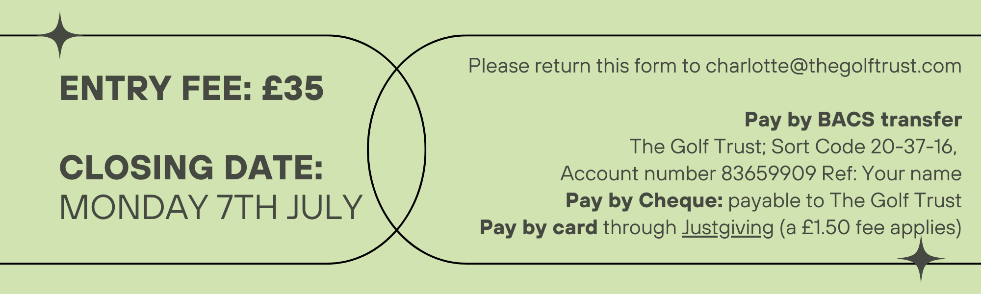

.*Payment to be received 7 days before the event